**Industrial Internship Report on**

**”Human Resource Management System”**

**Prepared by**

**[Priya Pathak]**

**[core java intern]**

|  |
| --- |
| *Executive Summary* |
| This report provides details of the Industrial Internship provided by upskill Campus and The IoT Academy in collaboration with Industrial Partner UniConverge Technologies Pvt Ltd (UCT).  This internship was focused on a project/problem statement provided by UCT. We had to finish the project including the report in 6 weeks’ time.  My project was “ Human Resource Management System”.  This internship gave me a very good opportunity to get exposure to Industrial problems and design/implement solution for that. It was an overall great experience to have this internship. |

**TABLE OF CONTENTS**

1 Preface 3

2 Introduction 4

2.1 About UniConverge Technologies Pvt Ltd 4

2.2 About upskills……………………………………………………………………………………………………………………………….9

2.3 Objective…………………………………………………………………………………………………………………………………….11

2.4 Reference…………………………………………………………………………………………………………………………………….11

2.5 Glossary……………………………………………………………………………………………………………………………………..11

3 Problem Statement…………………………………………………………………………………………………………………………….12

4 Existing and Proposed solution……………………………………………………………………………………………………………13

5 Proposed Design/model………………………………………………………………………………………………………………………15

5.1 High Level Diagram……………………………………………………………………………….………………………………………15

5.2 Low Level Diagram…………………………………………………………………………………………………………………………16

6 Performance Test………………………………………………………………………………………………………………………………..17

6.1 Test Plan/Test Cases..………………………………………………………………………………………………………………….17

6.2 Test Approach…………………………………………………………………………………………………………………………….19

6.3 Performance Outcome………………………………………………………………………………………………………………..20

7 My Learning………………………………………………………………………………………………………………………………………21

8 Future Scope……………………………………………………………………………………………………………………………………22

# Preface

I am delighted to present this preface section, summarizing my six weeks' worth of work on the Human Resource Management System (HRMS) project. This project was completed as part of a valuable internship program facilitated by Upskill Campus (USC) and Uniconverge Technology (UCT).

During this internship, I had the opportunity to explore the significance of relevant internships in career development. It provided me with hands-on experience in developing a comprehensive HRMS, which has undoubtedly enhanced my technical skills and deepened my understanding of the field.

The focus of this project was to address the existing challenges in human resource management by designing and implementing an efficient and user-friendly HRMS. The problem statement revolved around the need for a centralized system to manage employee records, attendance, leave, and salary generation. This project aimed to streamline these processes and improve overall HR efficiency within organizations.

The internship was organized in following manner:

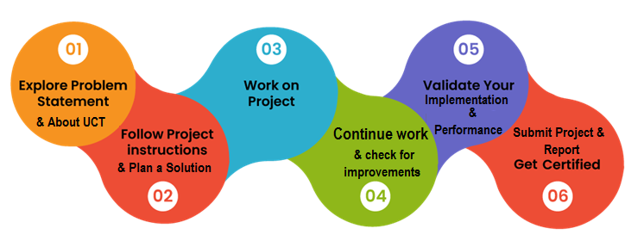Top of Form

The overall experience of working on the HRMS project has been enlightening and enriching. I have not only acquired technical skills in software development but have also gained a deeper understanding of the intricacies involved in designing and implementing an HRMS. This experience has provided me with a strong foundation for my future career aspirations in the field of human resource management and software development.

I express my sincere gratitude to USC and UCT for their support and faith in my abilities. This project report represents the culmination of my hard work, dedication, and the guidance I have received from the program and individuals involved. To my juniors and peers, I encourage you to seize every opportunity that comes your way. Embrace internships and practical projects, as they provide invaluable experiences and serve as stepping stones for your professional growth.

Thankyou

# Introduction

## About UniConverge Technologies Pvt Ltd

A company established in 2013 and working in Digital Transformation domain and providing Industrial solutions with prime focus on sustainability and RoI.

For developing its products and solutions it is leveraging various**Cutting Edge Technologies e.g. Internet of Things (IoT), Cyber Security, Cloud computing (AWS, Azure), Machine Learning, Communication Technologies (4G/5G/LoRaWAN), Java Full Stack, Python, Front end**etc.

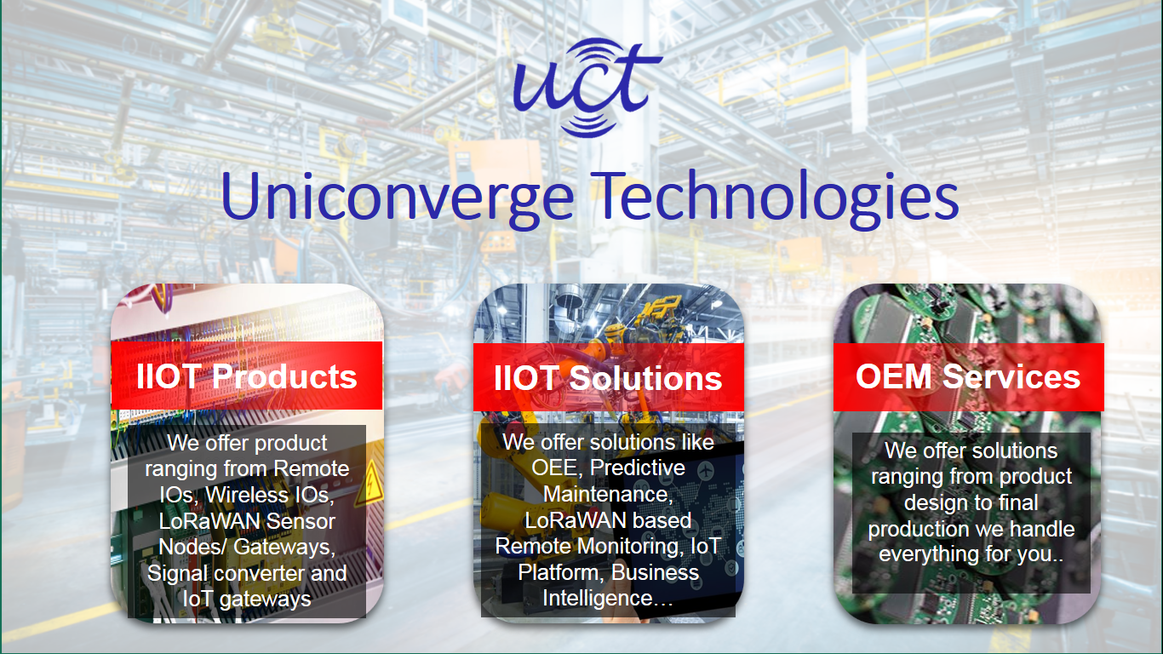

1. UCT IoT Platform **(****)**

**UCT Insight** is an IOT platform designed for quick deployment of IOT applications on the same time providing valuable “insight” for your process/business. It has been built in Java for backend and ReactJS for Front end. It has support for MySQL and various NoSql Databases.

* It enables device connectivity via industry standard IoT protocols - MQTT, CoAP, HTTP, Modbus TCP, OPC UA
* It supports both cloud and on-premises deployments.

It has features to  
• Build Your own dashboard  
• Analytics and Reporting  
• Alert and Notification  
• Integration with third party application(Power BI, SAP, ERP)  
• Rule Engine

 

1. **Smart Factory Platform (****)**

Factory watch is a platform for smart factory needs.

It provides Users/ Factory

* with a scalable solution for their Production and asset monitoring
* OEE and predictive maintenance solution scaling up to digital twin for your assets.
* to unleased the true potential of the data that their machines are generating and helps to identify the KPIs and also improve them.
* A modular architecture that allows users to choose the service that they what to start and then can scale to more complex solutions as per their demands.

Its unique SaaS model helps users to save time, cost and money.

 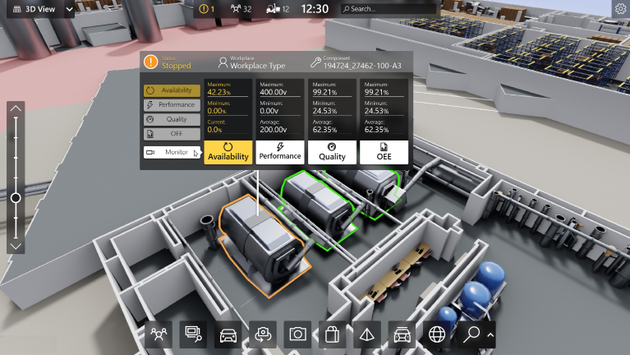

1. 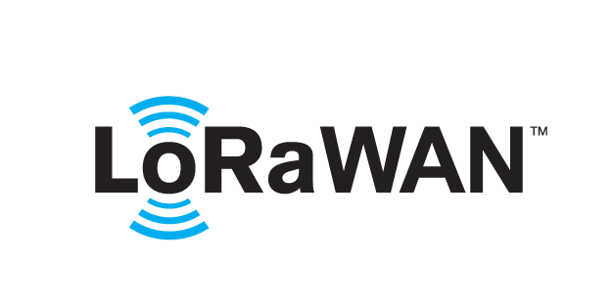 based Solution

UCT is one of the early adopters of LoRAWAN teschnology and providing solution in Agritech, Smart cities, Industrial Monitoring, Smart Street Light, Smart Water/ Gas/ Electricity metering solutions etc.

1. Predictive Maintenance

UCT is providing Industrial Machine health monitoring and Predictive maintenance solution leveraging Embedded system, Industrial IoT and Machine Learning Technologies by finding Remaining useful life time of various Machines used in production process.



## About upskill Campus (USC)

upskill Campus along with The IoT Academy and in association with Uniconverge technologies has facilitated the smooth execution of the complete internship process.

USC is a career development platform that delivers **personalized executive coaching** in a more affordable, scalable and measurable way.



Seeing need of upskilling in self paced manner along-with additional support services e.g. Internship, projects, interaction with Industry experts, Career growth Services

<https://www.upskillcampus.com/>

upSkill Campus aiming to upskill 1 million learners in next 5 year

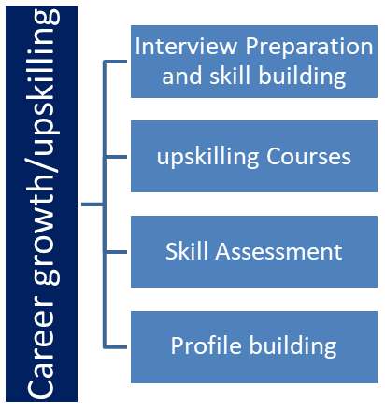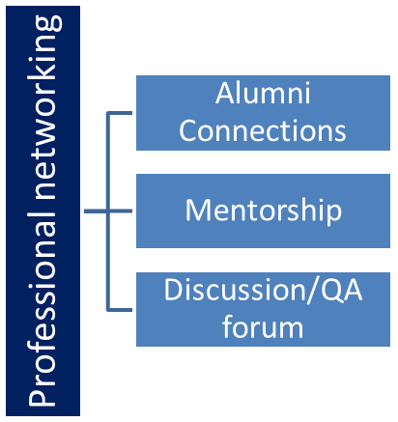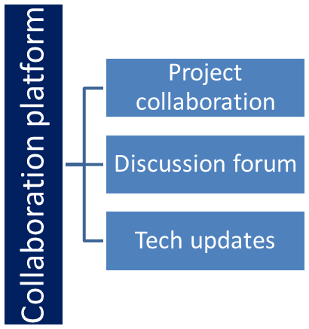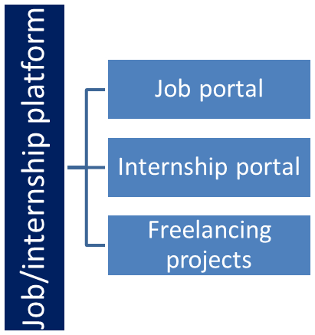

## The IoT Academy

The IoT academy is EdTech Division of UCT that is running long executive certification programs in collaboration with EICT Academy, IITK, IITR and IITG in multiple domains.

## Objectives of this Internship program

The objective for this internship program was to

 ☛ get practical experience of working in the industry.

 ☛ to solve real world problems.

 ☛ to have improved job prospects.

 ☛ to have Improved understanding of our field and its applications.

 ☛ to have Personal growth like better communication and problem solving.

## Reference

[1] <https://www.uniconvergetech.in/>

[2] <https://www.upskillcampus.com/>

[3] https://www.techtarget.com/iotagenda/definition/Internet-of-Things-IoT

## Glossary

|  |  |
| --- | --- |
| Terms | Acronym |
| LoRaWAN | Long Range Wide Area Network |
| MQTT | Message queuing telemetry transport |
| CoAP | Constrained Application Protocol |
| OPCUA | Open platform communication united architecture |
| IITK | Indian Institute of Technology Kanpur |

# Problem Statement

The Human Resource Management (HRM) process is a critical aspect of any organization, responsible for managing and optimizing the workforce. However, many organizations still rely on manual, paper-based systems or outdated software solutions to handle their HRM tasks. These traditional approaches often lead to inefficiencies, errors, and difficulties in accessing and analyzing HR-related data.

The aim of this project is to develop a comprehensive Human Resource Management System (HRMS) that addresses the limitations of existing systems and provides an efficient, user-friendly, and automated solution for managing HR-related processes.

The key problems identified in the current HRM practices are as follows:

* **Manual Data Management:** The reliance on manual data entry, paper-based files, and spreadsheets leads to errors, duplication, and difficulties in managing and updating employee records.
* **Inefficient Recruitment and Onboarding:** The current process for recruiting and onboarding new employees is time-consuming, paper-intensive, and lacks proper tracking and coordination.
* **Lack of Performance Evaluation Mechanisms:** The absence of a systematic performance evaluation system hinders the objective assessment of employees' performance and impedes effective talent management.
* **Attendance and Leave Management Challenges:** Managing attendance records, leave requests, and tracking employee absences is cumbersome and prone to errors when handled manually.
* **Ineffective Training and Development:** The current system lacks proper tracking and management of employee training and development programs, resulting in suboptimal skill enhancement and talent retention.

# Existing and Proposed solution

**Existing Solutions:**

Currently, many organizations rely on manual and outdated methods for managing their human resources. Some of the common existing solutions include:

* **Manual Paper-Based Systems:** Many organizations still use manual processes, such as paper-based files, spreadsheets, and physical attendance registers, to manage employee data, attendance, and leave records. These methods are time-consuming, error-prone, and lack efficiency.
* **Disparate Software Applications:** Some organizations utilize multiple standalone software applications for specific HR functions, such as payroll processing, recruitment, and performance evaluation. However, these fragmented systems often lack integration, leading to data duplication, inconsistencies, and difficulties in generating comprehensive reports.
* **Outdated HR Software:** A few organizations have invested in HR software solutions, but these Censystems are outdated, lack modern user interfaces, and do not address the evolving needs of HR management effectively. They may lack essential features or have limited scalability and customization options

**Proposed Solutions:**

The HRMS project aims to overcome the limitations of existing solutions and provide a comprehensive and efficient system for human resource management. The proposed solutions include:

* **Centralized Employee Database:** The HRMS will offer a centralized database to store and manage employee information, including personal details, employment history, skills, and performance records. This ensures accurate and up-to-date employee data accessible to authorized personnel.
* **Integrated Modules:** The HRMS will integrate various modules such as recruitment, onboarding, attendance management, leave management, performance evaluation, and training and development. This integration eliminates data silos, promotes data consistency, and allows seamless information flow across different HR functions.
* **Automation of Processes:** The HRMS will automate time-consuming and repetitive tasks, reducing manual effort and improving efficiency. For example, the system can automate candidate shortlisting, interview scheduling, leave requests, performance evaluations, and training program management.
* **Scalability and Customization**: The HRMS will be designed to accommodate the evolving needs of the organization. It will be scalable to handle a growing workforce and customizable to adapt to specific HR policies and processes.

===

## Code submission (Github link)

https://github.com/priya209/HRMS

## Report submission (Github link) :

https://github.com/priya209/HRMS

# Proposed Design/ Model

.

## High Level Diagram

**Admin/HR**

**Manage Employee Details**

**Manage Attendance Details**

**Manage Salary Details**

**Manage Leave Details**

**Manage HR rule details**

**Manage System Admins**

**Manage User Permission**

**Manage Roles of User**

Figure 1: HIGH LEVEL DIAGRAM OF THE SYSTEM

## 

## Low Level Diagram

**Employee Management**

**Login Management**

**Leave Management**

**System User Management**

**MDI Form Management**

**Salary Management**

# Performance Test

## Test Plan/ Test Cases

**6.1.1 Employee Record Management**

1. **Test Case 1:** Add New Employee

* **Description:** Verify that a new employee can be added successfully with all required information.
* **Test Steps:**
* Navigate to the employee management module.
* Click on "Add New Employee."
* Enter all the required employee details.
* Save the employee record.
* Verify that the employee record is successfully added to the database.

1. **Test Case 2:** Update Employee Information

* Description: Verify that the system allows updating employee information accurately.
* Test Steps:
* Select an existing employee from the employee list.
* Click on the "Edit" button.
* Modify employee information such as contact details or job title.
* Save the changes.
* Verify that the employee record is updated with the new information.

**6.1.2. Attendance and Leave Management**

1. **Test Case 3:** Record Attendance

* **Description:** Verify that the system accurately records employee attendance.
* **Test Steps:**
* Access the attendance module.
* Select a specific date.
* Mark the attendance of selected employees as "Present."
* Save the attendance records.
* Verify that the attendance records are saved accurately in the system.

1. **Test Case 4:** Submit Leave Request

* **Description:** Verify that employees can submit leave requests successfully.
* **Test Steps:**
* Access the leave management module.
* Click on "Submit Leave Request."
* Enter the required leave details (start date, end date, reason, etc.).
* Submit the leave request.
* Verify that the leave request is saved and pending for approval.

**6.1.3. Salary Generation**

1. **Test Case 5:** Generate Monthly Salary

* **Description:** Verify that the system accurately calculates and generates monthly salaries for employees.
* **Test Steps:**
* Access the salary generation module.
* Select the desired month and year.
* Click on "Generate Salary."
* Verify that the system calculates salaries accurately based on predefined rules and deductions.
* Verify that salary slips are generated for each employee.

## Test Procedure

# Test Setup: Set up the test environment to replicate the production environment as closely as possible, including the required hardware, software, and network configurations.Ensure that the HRMS application is installed and properly configured for testing.Prepare the necessary test data, including employee records, attendance information, and leave requests.

1. **Test Case Execution:** Execute each test case according to the defined test steps.Record the actual results observed during the test execution.If any issues or errors are encountered during the test execution, log them in the defect tracking system for further investigation and resolution.
2. **Test Data Management**:Ensure that the test data is correctly loaded into the HRMS application before executing the test cases.Regularly review and update the test data to cover different scenarios and edge cases.
3. **Defect Reporting:**If any defects are identified during the test execution, report them in a structured manner, including the steps to reproduce, expected results, and observed results.Assign a severity level to each defect based on its impact on the system's functionality and the priority of fixing it.
4. **Test Coverage and Traceability:**Track the test coverage to ensure that all the specified requirements and functionalities are adequately tested.Maintain a traceability matrix to establish a clear link between the test cases and the corresponding requirements.
5. **Regression Testing:** Perform regression testing after each bug fix or system change to ensure that the fixes or changes do not introduce new defects or impact existing functionality.
6. **Performance Testing:** Conduct performance testing using appropriate tools to evaluate the system's response time, scalability, and resource utilization under varying loads.Monitor and measure performance metrics such as response time, throughput, and resource consumption.Analyze the test results to identify any performance bottlenecks or areas for optimization.
7. **Security Testing:** Conduct security testing to assess the HRMS application's security controls, including access control, data encryption, and protection against common vulnerabilities.Perform penetration testing to identify any potential vulnerabilities or weaknesses in the system's security measures.
8. **User Acceptance Testing:** Involve end-users or stakeholders in user acceptance testing to validate that the HRMS meets their requirements and expectations.Collect feedback from users on the usability, functionality, and overall user experience of the system.
9. **Test Completion and Summary:** Review the test execution results and ensure that all test cases have been executed and reported.Summarize the overall test results, including the number of test cases passed, failed, and any outstanding defects.

## Performance Outcome

1. **Efficiency:** A properly designed HRMS can streamline HR processes, reducing manual effort and saving time. Tasks such as employee record management, attendance tracking, leave management, and salary processing can be automated, leading to increased efficiency and productivity in HR operations.
2. **Accuracy:** An HRMS eliminates the need for manual data entry and reduces the chances of errors and data inconsistencies. By centralizing employee data and automating data management, the system ensures that accurate and up-to-date information is available for HR personnel and employees.
3. **Time Savings:** The automation of routine HR tasks through an HRMS leads to significant time savings. HR personnel can focus on strategic activities and employee engagement rather than spending time on administrative tasks, resulting in increased productivity and effectiveness.
4. **Data Accessibility:** A well-implemented HRMS provides easy access to employee data, reducing the time and effort required to retrieve and analyze information. HR personnel can quickly access employee records, generate reports, and extract meaningful insights for decision-making and workforce planning.
5. **Scalability:** A well-designed HRMS can handle the growth of the organization and accommodate a larger employee base without sacrificing performance. The system should be scalable, allowing for the addition of new employees and the inclusion of new HR functionalities as the organization expands.
6. **Data Security:** An HRMS should prioritize data security and implement measures to protect sensitive employee information. This includes user authentication, data encryption, and access control to ensure that employee data remains confidential and secure.

**7. My learnings**

During the development of the Human Resource Management System project, I gained valuable knowledge and skills in various areas. The project provided me with a platform to enhance my technical expertise, deepen my understanding of HR processes, and develop important project management and communication skills. The following are the key learning outcomes from this project:

1. **Technical Skills Development:** Working on the HR Management System project allowed me to enhance my technical skills in several areas. I gained proficiency in core Java, Swing, AWT, and MySQL database management. This project provided hands-on experience in software development, including coding, debugging, and implementing software features.
2. **Understanding HR Processes:** Creating a Human Resource Management System required me to gain a thorough understanding of HR processes. Through extensive research and analysis, I deepened my knowledge of employee record management, attendance and leave management, and salary processing. This understanding enabled me to translate HR processes into functional software features effectively.
3. **Database Design and Management:** Designing and managing the MySQL database for the HR Management System project was a valuable learning experience. I acquired skills in database design, entity relationship modeling, and optimizing database queries. I learned how to create tables, establish relationships, and store and retrieve HR-related data efficiently.
4. **User Interface Design:** Developing an intuitive and user-friendly graphical user interface (GUI) was a significant aspect of the project. Through the use of Java Swing and AWT, I gained practical experience in UI design principles and created interactive forms and screens for HR management tasks. This learning helped me understand the importance of user experience (UX) design and usability considerations
5. **Testing and Quality Assurance:** Testing played a crucial role in ensuring the functionality and reliability of the HR Management System. I learned about different testing methodologies and gained experience in creating test cases, performing test executions, and identifying and fixing bugs. This learning emphasized the significance of quality assurance and the importance of delivering a robust software product.

.

Overall, the HR Management System project provided me with valuable learning opportunities, allowing me to strengthen my technical skills, deepen my understanding of HR processes, and develop essential project management and communication skills. These learning outcomes will undoubtedly benefit my future endeavors in software development and contribute to my professional growth.

# Future work scope

While the Human Resource Management System project has achieved significant milestones and delivered a functional system, there are several areas for potential future enhancements and developments. The following suggestions outline possible directions for future work on the HRMS:

* **Employee Self-Service Portal:** Developing an employee self-service portal as an extension of the HRMS would empower employees to access and manage their own HR-related information. This could include features such as viewing personal details, submitting leave requests, accessing training materials, and tracking performance goals.
* **Workflow Automation:** Introducing workflow automation features within the HRMS can streamline HR processes further. Automating routine tasks like performance evaluation reminders, leave request approvals, and training program notifications would save time and enhance process efficiency.
* **Mobile Application Support:** Designing and developing a mobile application for the HRMS would provide convenience and accessibility to employees and managers. Mobile app support would allow users to perform HR-related tasks, such as checking attendance records, submitting leave requests, and viewing salary details, using their mobile devices.
* **Enhanced Security Measures:** Strengthening the security measures of the HRMS would be a crucial consideration for future work. Implementing additional layers of security, such as multi-factor authentication and data encryption, would protect sensitive employee information and ensure compliance with data privacy regulations.

By pursuing these future work areas, the HRMS can be further enhanced to meet the organization's changing requirements, improve HR processes, and deliver an even more robust and comprehensive solution for effective human resource management.